SUPPLEMENTARY MATERIAL
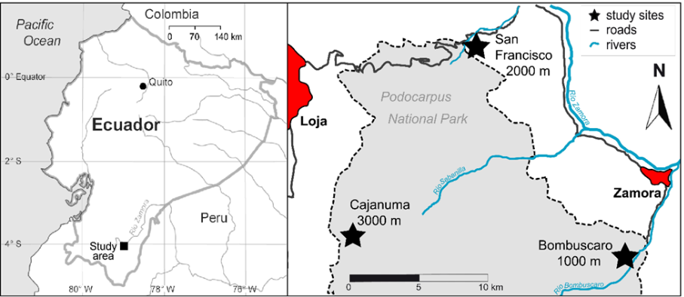

Fig 1. Experimental Design of the NUMEX plots in the South of Ecuador ​(Homeier et al., 2013a​​)​

Tab. 1: Physiogeographic and stand structural characteristics of the three study
sites. After Cárate-Tandalla et al., 2018
Site characteristics | Bombuscaro  1000m asl | San Francisco  2000m asl | Cajanuma  3000m asl
Location
Altitudinal range ª | 990-1100m asl | 2020-2100m asl | 2900-3020m asl
Coordinates ª | 4°7’ S, 78°58’ W | 3°58’ S, 79°11’ W | 4°7’ S, 79°11’ W
Temperature ^{b} | 19.4°C | 15.7°C | 9.4°C
Mean  precipitation ^{b} | 2230mm | 1950mm | 4500mm
Forest structure
Canopy height ª | 20-25m | 10-14m | 6-8m
Tree density ª | 748 trees/ha | 1143 trees/ha | 1305 trees/ha
Basal area (BA) ª | 33.4 m²/ha | 22.8 m²/ha | 25.5 m²/ha
Vegetation type ª | Evergreen  premontane forest | Evergreen lower  montane forest | Evergreen upper  montane forest
Soil type ª | Dystric Cambisol | Stagnic Cambisol | Stagnic Histosol
Organic layer depth ª | <1 cm | 10-30 cm | 10-40 cm
Total N organic soil ^{c}  mineral soil ª | 22 g/kg  6.0 g/kg | 19 g/kg  0.7 g/kg | 15 g/kg  0.7 g/kg
Total P ^{d}  organic soil mineral soil | 450 +/- 28 g/kg  220 +/- 36 g/kg | 527 +/- 22 g/kg  53 +/- 5 g/kg | 525+/- 47 g/kg  175 +/- 68 g/kg
ª Homeier, Leuschner, et al., 2013
^{b} Wittich et al., 2015
^{c} Iost, S. et al., 2008
^{d} Dietrich et al., 2016

Table S2. Overview of tree characteristics. A principal component analysis (PCA) based on soil C:N and foliar functional traits (Pierick et al., 2024) positioned the study species along an acquisitive–conservative resource-use spectrum. From the least to the most conservative, species were ordered as C. racemosa, P. torta, H. purpurascens, A. lojaensis, M. sp. nov., and Weinmania sp.

elevation | Vegetation Type | Familiy | specie | Wood density  (g/cm³  ) | Height (m) a | Maximum Diameter ^{b}
1000 | Evergreen premontane forest | Moraceae | Clarisia racemosa Ruiz & Pav | 0.59 | 20-40 | 50-120
 |  | Sapotaceae | Pouteria torta (Mart.) Radlk | 0.79 | 6-20 | 100-600
2000 | Evergreen lower montane forest | Euphorbiaceae | Alchornea lojaensis Secco | 0.52 | 9 | 235.56
 |  | Myrtaceae | Myrcia sp nov | 0.72 | 10 | 90-350
3000 | Evergreen upper montane forest | Chloranthaceae | Hedyosmun purpurascens Todzia | 0.49 | 3-8 | 226.92
 |  | Cunoniaceae | Weinmania loxensis  Harling | 0.54 | 4-7 | 139.36
ª Measured on site during fieldwork campaigns.
^{b} Maximum diameter based on estimation from datasets from forest dynamics. Values shaded in yellow for Maximum Height indicate preliminary estimates flagged in the original data source.

Table S2.
Trait | Unit | How it is measured
Ci/Ca | unitless | Calculated from δ13C following the Farquhar et al. (1982) photosynthesis discrimination model
iWUE (intrinsic water-use efficiency) | µmol/mol | Calculated from δ13C following the Farquhar et al. (1982) photosynthesis discrimination model
δ13C | ‰ vs. V-PDB | Measured by isotope ratio mass spectrometry (IRMS) on extracted leaf cellulose, expressed relative to the Vienna Pee Dee Belemnite standard
LNC (leaf nitrogen content) and LCC (leaf carbon content) | mg/g | Isotope Ratios Mass Spectrometer on bulk sample.
LPC (leaf phosphorus content) | mg/g | The leaf phosphorus content (LPC) was analyzed using an Inductively Coupled Plasma Analyzer (Optima 5300DV ICP-OES, Perkin Elmer) after digesting the samples with concentrated HNO3.
Narea | g/m² | Calculated from LNC and LMA: Narea = LNC × LMA
Parea | g/m² | Calculated from LPC and LMA: Parea = LPC × LMA
LDMC (leaf dry matter content) | mg/g | Ratio of oven-dried leaf mass to water-saturated fresh mass, following standardized protocols (Pérez-Harguindeguy et al. 2013)
Thickness | mm | Measured with a digital micrometer at multiple points on the lamina, avoiding the midrib and major veins
Toughness | kN/m | Measured with a device as the force required to shear/punch the lamina per unit width or thickness
SLA (specific leaf area) | cm²/g | Fresh leaf area (before drying) divided by oven-dried leaf mass.
LMA (leaf mass per area) | g/m² | Oven-dried leaf mass divided by fresh leaf area (before drying); reciprocal of SLA (LMA = 10,000 / SLA)
Leaf area | cm² | Measured from scanned leaf images using image analysis software (e.g., ImageJ).

Figure S3. To assess whether leaf δ¹³C varied along the elevational gradient, we fitted a linear mixed-effects model with elevation as a fixed effect and Site as a random effect. No significant relationship was found between δ¹³C and elevation (β = −0.0001, SE = 0.0004, z = −0.27, p = 0.79). Consistent with this result, the scatterplot showed substantial variation in δ¹³C values across the elevational gradient without a clear directional trend.
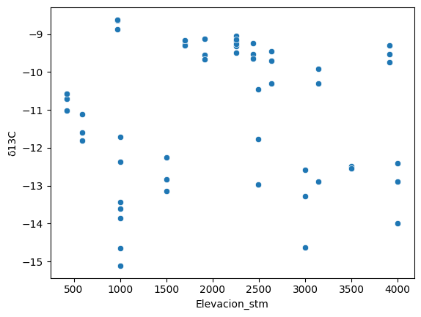
Table SX. Summary of foliar traits per specie, elevation and treatment.
Values expressed as mean ± standard deviation (SD). C = control, N = Nitrogen addition, P = Phosphorus addition, N+P = combined addition.
Elevación (m) | Especie | Treatment. | δ13C (‰) | iWUE (µmol/mol) | LNC (mg/g) | LPC (mg/g) | LCC (mg/g) | Narea (g/m²) | Parea (g/m²) | N:P (—) | C:N (—) | LMA (g/m²)
1000 | Clarisia racemosa | Control | -30.63 ± 0.42 | 37.0 ± 5.2 | 17.4 ± 2.6 | 0.79 ± 0.05 | 421.4 ± 14.4 | 1.890 ± 0.220 | 0.090 ± 0.010 | 21.9 ± 2.2 | 24.5 ± 2.9 | 109.6 ± 13.0
 |  | N | -31.80 | 22.6 | 20.1 | 0.96 | 447.1 | 1.790 | 0.090 | 20.9 | 22.3 | 89.2
 |  | P | -29.84 ± 1.24 | 46.6 ± 15.2 | 19.6 ± 2.7 | 1.17 ± 0.17 | 438.3 ± 12.7 | 2.050 ± 0.250 | 0.120 ± 0.020 | 16.9 ± 2.6 | 22.6 ± 3.1 | 104.9 ± 6.6
 |  | N+P | -30.88 ± 0.36 | 34.0 ± 4.4 | 23.6 ± 1.5 | 1.15 ± 0.14 | 430.5 ± 14.1 | 2.190 ± 0.070 | 0.110 ± 0.020 | 20.8 ± 3.5 | 18.3 ± 1.7 | 92.8 ± 7.3
1000 | Pouteria torta | Control | -31.55 ± 0.76 | 25.6 ± 9.3 | 15.3 ± 1.3 | 0.65 ± 0.12 | 478.0 ± 5.3 | 1.920 ± 0.220 | 0.080 ± 0.010 | 24.4 ± 5.2 | 31.0 ± 2.3 | 125.8 ± 12.1
 |  | N | -31.27 ± 0.87 | 40.2 ± 22.4 | 15.7 ± 1.2 | 0.64 ± 0.20 | 480.5 ± 6.2 | 2.050 ± 0.260 | 0.080 ± 0.010 | 25.9 ± 5.4 | 31.0 ± 2.4 | 131.6 ± 22.5
 |  | P | -31.27 ± 0.93 | 29.1 ± 11.5 | 16.7 ± 1.5 | 0.77 ± 0.13 | 479.2 ± 5.5 | 2.170 ± 0.320 | 0.100 ± 0.010 | 22.5 ± 5.1 | 28.9 ± 2.2 | 130.5 ± 19.7
 |  | N+P | -31.74 ± 1.35 | 23.4 ± 16.6 | 16.4 ± 1.0 | 0.73 ± 0.07 | 477.9 ± 5.2 | 2.070 ± 0.160 | 0.090 ± 0.010 | 22.6 ± 1.8 | 29.3 ± 1.7 | 127.2 ± 14.0
2000 | Alchornea lojaensis | Control | -26.51 ± 0.89 | 87.6 ± 10.8 | 11.6 ± 1.5 | 0.78 ± 0.12 | 489.9 ± 9.2 | 3.270 ± 0.410 | 0.220 ± 0.040 | 15.1 ± 2.2 | 43.0 ± 6.9 | 283.9 ± 33.0
 |  | N | -26.57 ± 1.13 | 86.9 ± 13.7 | 13.1 ± 1.8 | 0.79 ± 0.15 | 487.7 ± 10.1 | 3.590 ± 0.640 | 0.210 ± 0.040 | 16.8 ± 1.8 | 37.7 ± 4.8 | 272.7 ± 24.7
 |  | P | -27.06 ± 1.51 | 81.0 ± 18.3 | 11.1 ± 1.4 | 1.24 ± 0.28 | 486.9 ± 5.1 | 3.140 ± 0.570 | 0.350 ± 0.090 | 9.4 ± 2.3 | 43.4 ± 4.3 | 283.3 ± 42.2
 |  | N+P | -26.77 ± 1.45 | 84.4 ± 17.6 | 12.0 ± 1.6 | 1.32 ± 0.33 | 490.6 ± 10.4 | 3.510 ± 0.530 | 0.390 ± 0.120 | 9.6 ± 2.3 | 40.5 ± 4.7 | 292.2 ± 28.7
2000 | Myrcia sp nov | Control | -27.79 ± 1.15 | 72.0 ± 14.0 | 8.8 ± 1.2 | 0.43 ± 0.17 | 472.4 ± 9.4 | 2.430 ± 0.310 | 0.120 ± 0.060 | 22.9 ± 4.0 | 54.2 ± 6.9 | 279.2 ± 30.0
 |  | N | -27.24 ± 0.92 | 78.7 ± 11.1 | 10.0 ± 0.8 | 0.43 ± 0.03 | 470.9 ± 6.8 | 2.820 ± 0.180 | 0.120 ± 0.010 | 23.5 ± 2.2 | 47.4 ± 4.1 | 283.6 ± 21.2
 |  | P | -27.34 ± 0.66 | 77.6 ± 8.1 | 8.2 ± 0.9 | 1.70 ± 0.66 | 469.9 ± 10.0 | 2.400 ± 0.310 | 0.500 ± 0.230 | 6.3 ± 5.0 | 58.0 ± 6.3 | 294.0 ± 34.9
 |  | N+P | -27.27 ± 1.00 | 78.3 ± 12.2 | 9.8 ± 0.8 | 0.88 ± 0.36 | 464.6 ± 6.0 | 2.730 ± 0.170 | 0.240 ± 0.100 | 12.4 ± 3.7 | 47.8 ± 4.2 | 280.1 ± 20.7
3000 | Hedyosmun purpurascens | Control | -26.81 ± 1.44 | 83.8 ± 17.6 | 14.3 ± 1.1 | 0.84 ± 0.08 | 438.0 ± 6.1 | 2.150 ± 0.390 | 0.120 ± 0.020 | 17.2 ± 1.0 | 30.8 ± 2.8 | 151.7 ± 36.1
 |  | N | -26.35 ± 2.06 | 89.3 ± 25.1 | 17.5 ± 3.6 | 0.80 ± 0.05 | 434.9 ± 10.1 | 2.850 ± 0.280 | 0.130 ± 0.010 | 21.8 ± 4.2 | 25.8 ± 5.3 | 165.8 ± 16.4
 |  | P | -27.29 ± 1.59 | 77.9 ± 19.4 | 15.7 ± 1.5 | 1.42 ± 0.44 | 436.7 ± 6.0 | 2.120 ± 0.460 | 0.190 ± 0.070 | 12.2 ± 3.8 | 28.1 ± 2.5 | 134.8 ± 22.2
 |  | N+P | -24.85 ± 1.27 | 107.6 ± 15.4 | 17.1 ± 1.7 | 1.07 ± 0.08 | 442.7 ± 6.6 | 2.590 ± 0.230 | 0.160 ± 0.010 | 15.9 ± 0.4 | 26.1 ± 2.8 | 152.2 ± 12.1
3000 | Weinmania loxensis | Control | -27.70 ± 0.27 | 72.9 ± 3.3 | 10.4 ± 1.3 | 0.56 ± 0.05 | 444.1 ± 7.8 | 1.480 ± 0.080 | 0.080 ± 0.010 | 18.6 ± 1.7 | 43.1 ± 5.8 | 143.5 ± 13.3
 |  | N | -28.06 ± 0.90 | 68.5 ± 10.9 | 11.5 ± 1.8 | 0.61 ± 0.05 | 445.5 ± 14.2 | 1.670 ± 0.300 | 0.090 ± 0.020 | 18.9 ± 2.0 | 39.5 ± 5.2 | 146.0 ± 19.9
 |  | P | -28.38 ± 1.13 | 64.5 ± 13.8 | 10.7 ± 1.7 | 1.64 ± 0.44 | 440.6 ± 11.2 | 1.480 ± 0.260 | 0.230 ± 0.060 | 7.3 ± 3.4 | 41.7 ± 5.2 | 138.1 ± 7.5
 |  | N+P | -29.03 ± 0.79 | 56.6 ± 9.7 | 11.2 ± 0.1 | 0.72 ± 0.07 | 460.1 ± 9.1 | 1.550 ± 0.120 | 0.100 ± 0.000 | 15.6 ± 1.3 | 41.2 ± 0.3 | 139.0 ± 12.3
Note: The treatments without SD correspond to a unique simple (n=1)). Abbreviations: δ13C = isotopic discrimination of foliar carbon; iWUE = intrinsic wáter use efficiency; LNC/LPC/LCC = leaf content of N/P/C; Narea/Parea = N/P per unit of foliar area; LMA =leaf mass area.

Figure S1. Boxplots of (a) intrinsic water-use efficiency (iWUE), (b) leaf nitrogen content (LNC), (c) leaf phosphorus content (LPC), and (d) leaf N:P ratio from the control plots. Boxes represent the interquartile range, the central line indicates the median, and points represent individual observations. Different letters indicate significant differences among species based on one-way ANOVA followed by Tukey's HSD post hoc test (P < 0.05).
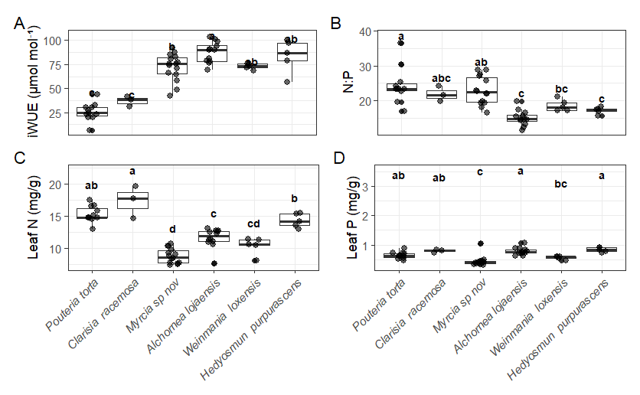

SECTION: MODELS

Table SX. Model selection: additive (N+P) vs interaction (NxP)
Lineal mixed models (lmer, REML, método de Satterhwaite) with Block as random effect, adjusted to each specie. Block was maintained to keep the structure of the experimental design.
 | Species | n | AIC additive | AIC interaction | χ² (1) | p (LRT) | Selected model
1000 | Pouteria torta | 36 | 310.44 | 308.59 | 3.848 | 0.0498 * | N*P
 | Clarisia racemosa | 12 | 94.56 | 96.54 | 0.024 | 0.877 | N+P
2000 | Alchornea lojaensis | 45 | 377.25 | 379.02 | 0.230 | 0.632 | N+P
 | Myrcia sp. nov | 50 | 394.91 | 396.05 | 0.856 | 0.355 | N+P
3000 | Hedyosmun purpurascens | 21 | 193.86 | 193.90 | 1.960 | 0.162 | N+P
 | Weinmania loxensis | 18 | 141.62 | 143.50 | 0.129 | 0.720 | N+P
Model selection was performed using likelihood ratio tests (LRT) comparing models fitted by maximum likelihood (ML). The additive model was retained when the interaction term did not significantly improve model fit (p > 0.05, ΔAIC < 2). For Pouteria, the interaction model provided a statistically significant but marginal improvement in model fit (p = 0.0498), with only a small reduction in AIC (ΔAIC = 1.85).

